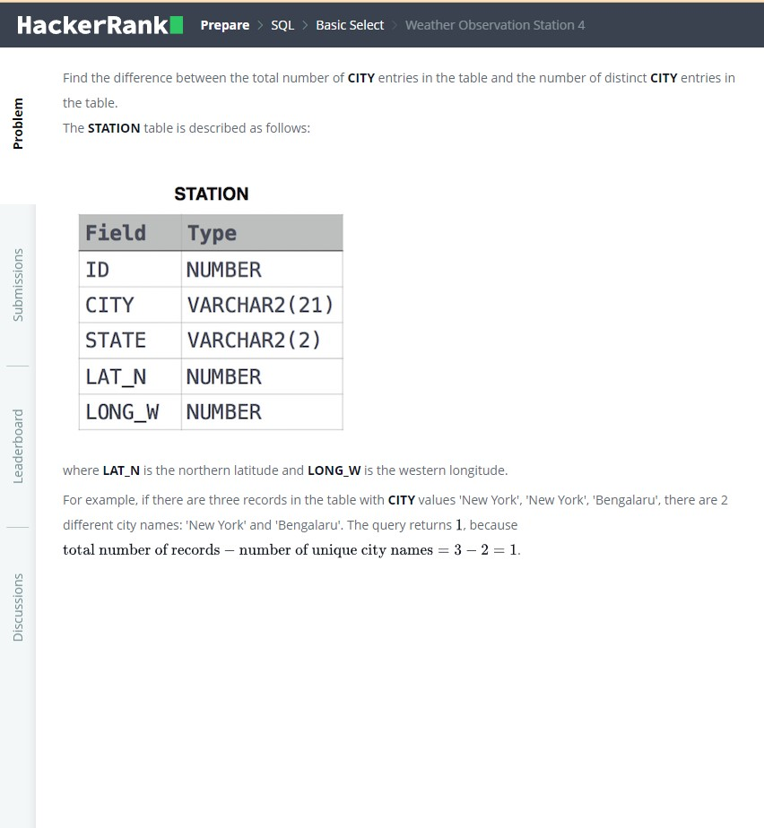

Output

SELECT (COUNT(CITY)-COUNT(DISTINCT(CITY)))

FROM STATION;